Transcription
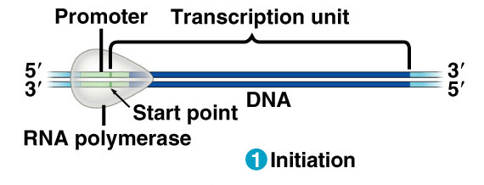
Initiation
- RNA polymerase binds to DNA at a region called the promoter

Elongation
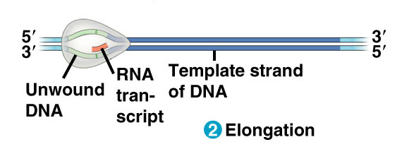
- RNA Polymerase builds the mRNA in the 5’ 3’ direction using complementary base pairing.
- The strand transcribed is called the template or anti-sense strand. (has the opposite base sequence as mRNA)
- Template strand runs 3’ 5’
- The strand NOT transcribed is called the coding or sense strand (has the same base sequence as mRNA). Coding strand runs 5’ 3’.
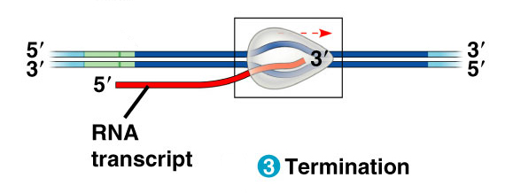
Termination
- Polymerase stops when it reaches a DNA sequence called the terminator
- The mRNA has been completely transcribed
- In eukaryotes, this is pre-mRNA and must be further processed before exiting the nucleus

