IB Biology: Proteins & Enzymes Review (2.4, 2.5, & 7.3) NAME:
- Draw a generalized amino acid:

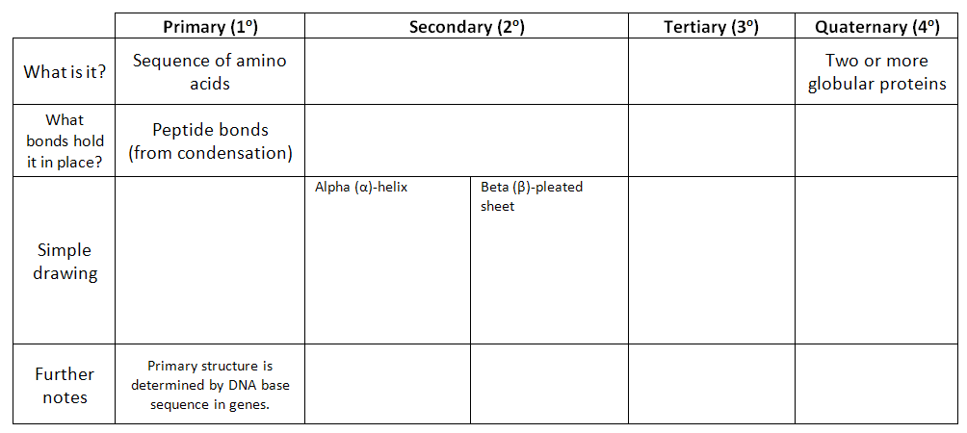
- Explain the four levels of protein structure:
- Explain how changes in pH and temperature lead to denaturation of proteins:

- Outline the significance of these structures in the R-groups (side-chains) of amino acids (think about what type of bonds they might form in either secondary or tertiary structures).
- Polar R-groups:
- Non-polar R-groups:
- Positively or negatively charged R-groups:
- Sulphur-containing R-groups:
- Compare fibrous and globular proteins:
 | Fibrous | Globular
What does it look like?
Solubility
Functions
Examples

- Proteins are used on the plasma membrane and for other diverse functions. Complete the table below:
Protein Function | Example | What does it do?
Gas / Nutrient Transport
Catalyst / Enzyme
Immunity / Defense
Hormones
Structure / Tensile Strength
Movement / Muscle Contraction
DNA Packaging

- Complete the table describing the functions of the six specific protein example, below:
Protein Example | Function
Rubisco
Insulin
Immunoglobulin (Antibodies)
Collagen
Rhodopsin
Spider silk

- Define the following:
enzyme | “globular protein which acts as a catalyst for biological reactions”
active site
denaturation

- List three examples of enzymes, with their functions.
- ________________________________________________________________________
- ________________________________________________________________________
- ________________________________________________________________________
- Explain enzyme-substrate specificity. Include a diagram:

- State the function of polar regions of amino acids on the active site of the enzyme.

- Explain the lowering of activation energy by enzymes.
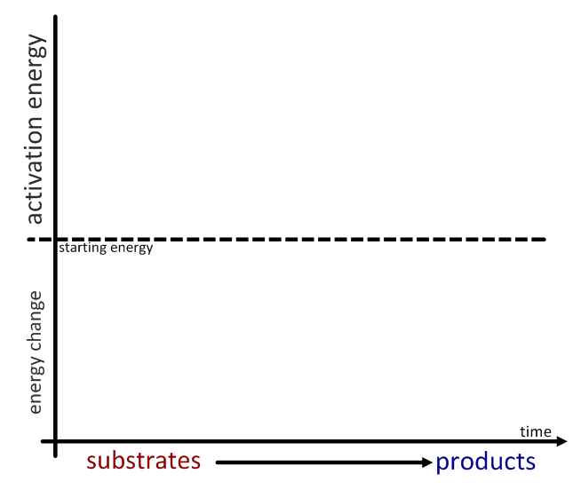

- Explain the effects of temperature, pH and substrate concentration on the rate of an enzyme-controlled reaction. Draw a sample graph in the space on the left and then explain/ describe on the right:
Temperature
pH
Substrate concentration
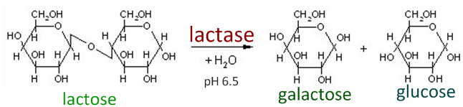
- Explain the industrial production of lactose-free milk, including two advantages of lactose-free milk:

