IB Biology HL: DNA Structure & Replication Review NAME:

- Draw a single nucleotide, labeling the phosphate, deoxyribose sugar and nitrogen base, in the box to the right:

- Compare DNA and RNA.
DNA | RNA
Similarities:
Differences:

- Draw and label a double stranded segment of DNA with four nucleotides (arranged in two base pairs):

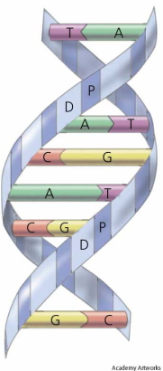

- The diagram shows a DNA double helix. How does a double helix form? What bonds hold it in position?

- Draw and label a nucleosome:

- What are the functions of nucleosomes?

- Describe what is meant by ‘Highly-repetitive DNA sequences’ and list several functions of these sequences.

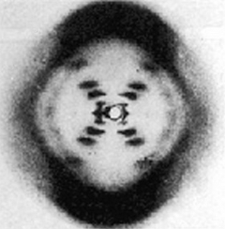
- What information did Rosalind Franklin’s X-ray image show about the structure of DNA?

- Outline how the Hershey-Chase experiment showed DNA, not protein, was the genetic material.

- What is the main purpose of replicating DNA?

- Explain the meaning of ‘DNA replication is semi-conservative’.

- How does complementary base pairing ensure the accuracy of the new strand of DNA?

- Describe how the Polymerase Chain Reaction (PCR) works, including the role of Taq DNA Polymerase:

- Complete the table with the functions of these five enzymes involved in DNA replication.
Enzyme | Function
Helicase
DNA Primase
DNA Polymerase III
DNA Polymerase I
DNA Gyrase (Topoisomerase)
DNA Ligase

- What are Okazaki fragments?

- In which direction does DNA replication occur?

- Describe the use of Dideoxyribnonucleotides to sequence unknown DNA samples.

