11.2 – Muscles and Movement
Text Reference: Raven – Chapter 47: 47.3 – Joints and skeletal movement/ 47.4 – Muscle Contraction

- Explain why muscles occur in antagonistic pairs.
- Distinguish between a tendon and a ligament?
- Outline the functions of cartilage and synovial fluid in the elbow joint.
- Compare the movement of a hinge joint and a ball-and-socket joint.
- Explain how actin and myosin filaments produce the striped appearance of skeletal muscle.
- Explain the contraction of skeletal muscle. What is the role of actin and myosin? Include the roles of the proteins involved, Ca²⁺, and ATP.
- Label the structures of the sarcomere:
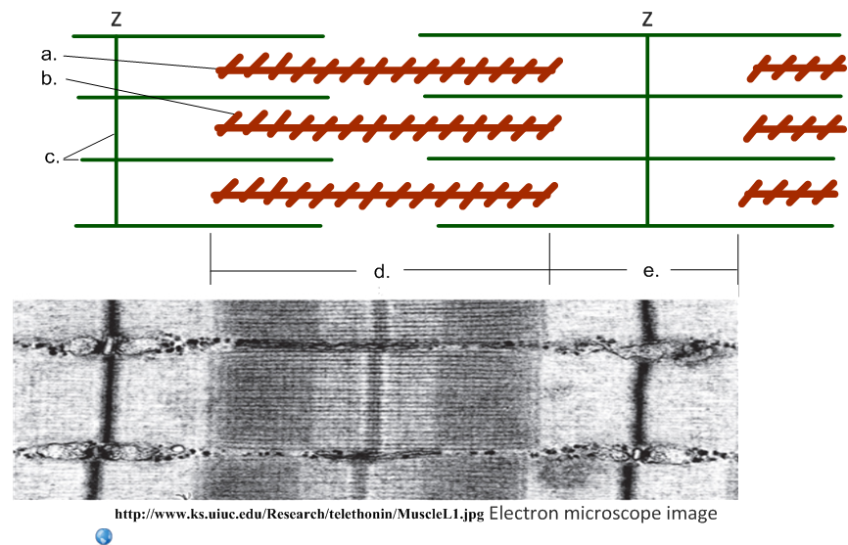
a.

b.

c.

d.

e.
- Identify the number of complete number of sarcomeres in this EM image:
Sarcomeres =
- Compare these two electron micrographs of a skeletal muscle sarcomere.

Contracted or relaxed?
Sarcomere length |  | Shorter
Z-bands |  | Closer
H-bands | No change
Light bands
Dark bands | No change
- Deduce the relative roles of actin and myosin fibres from this image:
- Myosin fibres move, actin fibres remain in position.
- Actin fibres move, myosin fibres remain in position.
- Both actin and myosin fibres move.
- Neither actin nor myosin fibres move.

