SBI4U7 - Topic 9 – 9.1 & 9.2 Review Questions

1. The diagram below shows a cross section of a stem. What is the structure labelled Y and one of its functions?
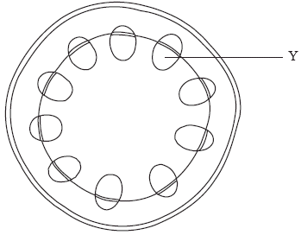

 | Structure Y | Function
A. | phloem | storage of water and starch
B. | xylem | mechanical support
C. | phloem | gas exchange
D. | xylem | transport of sugars

2. What part of the human body is most similar in function to the spongy mesophyll layer in a leaf?
A. Alveoli in the lungs
B. Erythrocytes in the blood
C. Villi in the small intestine
D. Sweat glands in the skin

3. How do mineral ions in the soil move to the root through the soil?
A. Osmosis
B. Mass flow of water
C. Translocation
D. Through phloem

4. How are fluids transported in the xylem and the phloem?
 | Xylem | Phloem
A. | away from the root only | towards the root only
B. | towards the root only | away from the root only
C. | away from and towards the root | towards the root only
D. | away from the root only | away from and towards the root

5. What is a difference between the features of monocotyledons and dicotyledons?
 | Monocotyledons | Dicotyledons
A. | Tap roots | Fibrous roots
B. | Two seed-leaves | One seed-leaf
C. | Vascular tissue in rings in the stem | Vascular tissue scattered through the stem
D. | Parallel-veined leaves | Net-veined leaves

6. What causes stomata to close?
A. Increase in the turgor of the guard cells
B. A high level of CO2 in the leaf tissues
C. The presence of abscisic acid
D. Movement of K+ into the guard cells

7. What are the main structures in a bulb and their function?
A. Flowers for sexual reproduction
B. Enlarged roots for nutrient absorption from the soil
C. Swollen leaf bases for food storage
D. Thickened stems for water storage

8. (a) State two types of meristem found in plants. [1]

.....................................................................................................................................

.....................................................................................................................................

(b) Outline two differences in structure between monocotyledonous and dicotyledonous plants. [2]
Structure | Monocotyledonous | Dicotyledonous

(c) State two methods by which terrestrial plants support themselves. [2]

.....................................................................................................................................

.....................................................................................................................................

(d) Explain how auxin controls the response of a plant to light. [3]

.....................................................................................................................................
.....................................................................................................................................
.....................................................................................................................................
.....................................................................................................................................
.....................................................................................................................................
.....................................................................................................................................

9. (a) The main parts of growing plants are roots, stems and leaves. Draw a plan diagram to show the arrangement of tissues in the stem of a dicotyledonous plant. (5)

(b) Outline the adaptations of plant roots for absorption of mineral ions from the soil.
(5)
(c) Describe how water is carried by the transpiration stream.
(7)
(d) Outline adaptations of xerophytes.
(4)

