An Overview of Protein Synthesis

- DNA is located in the nucleus of the cell and is unable to leave the nucleus.
- However, proteins are assembled in the cytoplasm with the help of ribosomes.
- So how does the information, encoded in DNA, for the synthesis of proteins get to the ribosomes in the cytoplasm?
= RNA!!!

CENTRAL DOGMA

DNA RNA Protein
Transcription Translation

Types of RNA:
- mRNA = messenger RNA – carries the code for the protein to the ribosome. Made from the DNA template.

- tRNA = transfer RNA – transfers amino acids from the cytoplasm to the ribosome for polypeptide synthesis.

- rRNA = ribosomal RNA – structural component of ribosomes. Provides the site where polypeptides are assembled.

One Gene-One Polypeptide Hypothesis
- Theory: one gene codes for one polypeptide
- Some proteins are composed of a number of polypeptide chains. In this theory each chain has its own gene.
- However, eukaryotic genes are much more complex and this is not always the case!
  - Some genes control the expression of other genes
  - Some genes code for RNA which do not produce polypeptides

TWO MAJOR STAGES OF PROTEIN SYNTHESIS:
Recall:
Thymine (T) is not present in RNA and is replaced with Uracil (U)

1) Transcription: DNA RNA
- Occurs in the nucleus of the cell
- Transcribes the DNA code into RNA

2) Translation: RNA polypeptide (protein)
- Occurs in the cytoplasm of the cell
- Translates the RNA into an amino acid sequence

Parent DNA strand: A – T – C – A – T – G – G – C – T – A

Transcribed RNA strand: THE GENETIC CODE
U – A – G – U – A – C – C – G – A – U
- The genetic code identifies the nucleotide combinations responsible for the each of the 20 known amino acids.
- There are 4 bases which operate in sets of 3 (a triplet).= 4³possible triplets of DNA =64 triplets
- 1 codon = 1 amino acid
- The genetic code is degenerate - More than one codon codes for an amino acid
- The genetic code is universal. ……well…..ALMOST!
  - Supports strong evidence of evolutionary relationships between organisms
  - This allows gene transfer between organisms
  - DNA in mitochondria and chloroplasts is different in prokaryotes and eukaryotes
  - Some protists have different codons for some amino acids
- One codon serves as the START codon (AUG – Methionine)
- Many codons code for STOP signals

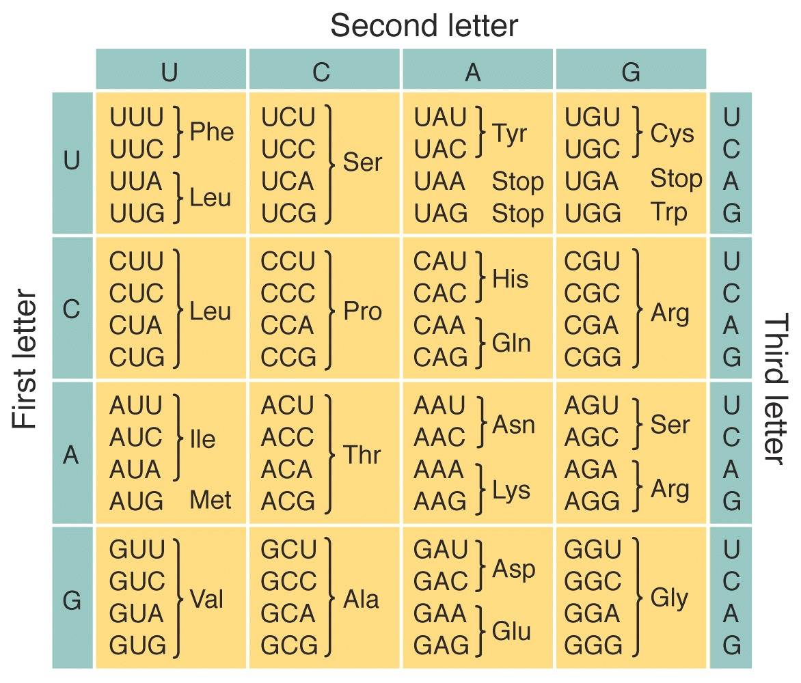
U – A – G – U – A – C – C – G – A – U

Stop-Tyr-Arg

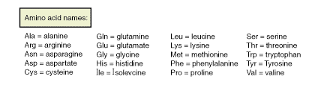

TRANSCRIPTION

DS DNA SS mRNA
Location: Nucleus
Enzyme: RNA Polymerase
Function: creates the mRNA by adding complementary bases (free nucleoside triphosphates) in the 5’ to 3’ direction.

DNA has 2 strands….
- Anti-sense strand (Template strand) – the strand of DNA that is transcribed. Has the complementary genetic code of the mRNA.
The tRNA will have the same base sequence as the anti-sense strand (except U instead of T)

- Sense strand (coding strand) – the strand of DNA that is not transcribed. It has the same genetic code as the mRNA (except U instead of T).
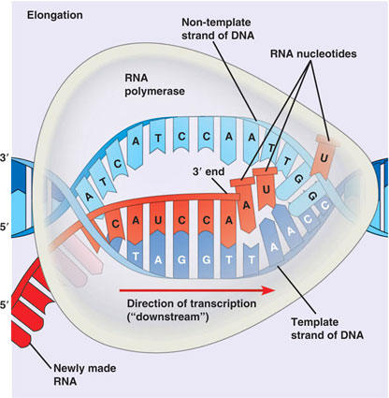
Sense Strand
Anti -Sense Strand

TRANSCRIPTION CON’T

Step 1: INITIATION

- RNA polymerase (an enzyme) binds to a specific site on the DNA anti-sense (template) strand, called a promoter. Usually a repetitive sequence of bases.

Step 2: ELONGATION

- RNA polymerase builds the mRNA by adding complementary bases (nucleoside triphosphates) in the 5’ to 3’ direction using the anti-sense strand as a template.

Step 3: TERMINATION

- Once the gene is completely transcribed, it recognizes a terminator sequence encoded in the DNA.
- mRNA is released from the DNA and post transcriptional modifications are made.
- Mature mRNA then leaves the nucleus to the cytoplasm.

Once the information from the Parent DNA strand is read, the DNA strand will recoil and go back to its double-stranded form.

Post Transcriptional Modifications
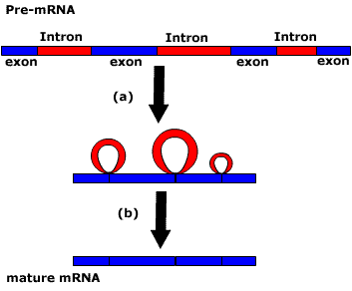

- The entire gene is transcribed, but only the coding portion is sent to the cytoplasm to be translated

TRANSLATION

mRNA Polypeptide
Location: Cytoplasm
Components involved: Ribosome, tRNA, amino-acyl tRNA synthetase
Function: Creates the polypeptide chain by reading the mRNA code in triplet. tRNA adds amino acids in order as dictated by the code. mRNA is read in the 5’ to 3’ direction

RIBOSOME STRUCTURE

Composed of rRNA and proteins

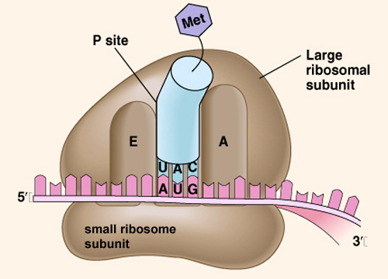

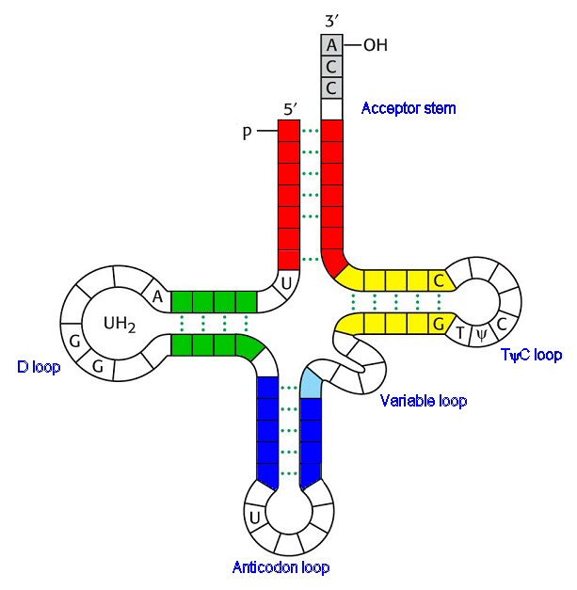
tRNA STRUCTURE
Amino acid attachment site
Loops include unpaired bases
Hydrogen bonds join strands

TRANSLATION CON’T

Step 1: INITIATION
- A ribosome recognizes a specific sequence in the mRNA. The small subunit binds.
- 1st tRNA carrying methionine (MET) binds to the start codon (AUG)
- The large subunit of the ribosome binds

Step 2: ELONGATION
- The ribosome then moves along the mRNA strand, only 3 nucleotides at a time (1 codon).
- Each set of three nucleotides codes for a specific amino acid (genetic code).
- A tRNA activating enzyme attaches the appropriate amino acid to the tRNA molecule. This uses ATP.
- The tRNA molecule delivers the appropriate amino acid to the ribosome.
- The first tRNA attaches to the P-site. The second tRNA attaches to the A site. A peptide bond forms between the two amino acids.

Peptide bond formation
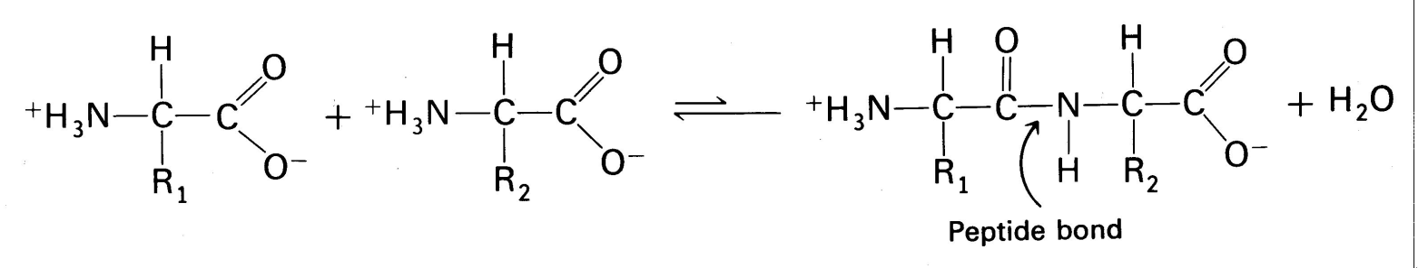
Step 3: TRANSLOCATION
- The ribosome translocates ONE codon along the mRNA
- The growing chain moves to the P-site. The 3rd tRNA attaches to the A-site. The 1st tRNA (without an aa attached) is ejected from the E-site.
- This ribosome moves a codon at a time along the mRNA until a STOP codon is reached. Peptide bonds are formed between each amino acid.

Step 4: TERMINATION
- When the ribosome reaches a STOP codon elongation stops. (A STOP codon does not code for an amino acid.)
- Release factor enters and the polypeptide is released. The ribosome breaks apart.

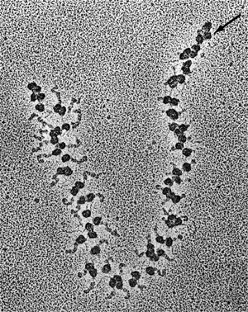
POLYSOMES

- Proteins produced on bound ribosomes (RER) are for export out of the cell or lysosomes.
- Proteins produced on free ribosomes are for use inside the cell.

