9.4 – Reproduction In Plans
Understandings, Applications and Skills (This is what you may be assessed on)
 | Statement | Guidance
9.4 U.1 | Flowering involves a change in gene expression in the shoot apex
9.4 U.2 | The switch to flowering is a response to the length of light and dark periods in many plants
9.4 U.3 | Success in plant reproduction depends on pollination, fertilization and seed dispersal
9.4 U.4 | Most flowering plants use mutualistic relationships with pollinators in sexual reproduction
9.4 A.1 | Methods used to induce short-day plants to flower out of season.
9.4 S.1 | Draw internal structure of seeds.
9.4 S.2 | Drawing of half-views of animal-pollinated flowers.
9.4 S.3 | Design of experiments to test hypothesis about factors affecting germination.

9.4 U.1 Flowering involves a change in gene expression in the shoot apex

- Describe how a change in vegetative structure occurs to create a flower.

9.4 U.2 The switch to flowering is a response to the length of light and dark periods in many plants

- Distinguish between long-day and short-day plants in terms of conditions required for flowering

- Define phytochrome

- Distinguish between red light and far-red light wavelength

- Use the diagram below to explain the interconversion of phytochromes between daylight and darkness
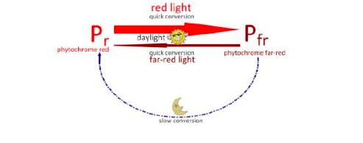
- Explain how phytochromes control flowering in short-day plants

- Explain how phytochromes control flowering in long-day plants

9.4 A.1 Methods used to induce short-day plants to flower out of season.

- Identify factors that are changed to induce flowering.

9.4 U.3 Success in plant reproduction depends on pollination, fertilization and seed dispersal

- Describe the process of fertilization in a flowering plant
Begin with the pollen grain on the stigma. Identify the site of seed development.

9.4 U.4 Most flowering plants use mutualistic relationships with pollinators in sexual reproduction

- Describe the process of fertilization in flowering plants. .

- Discuss TWO mechanisms of pollen transfer and the adaptations facilitate each mechanism

- Explain two advantages of dispersing seeds over a wide area

9.4 S.1Draw internal structure of seeds.

- Draw a diagram to show the structure of a seed (Label, and include functions of, micropyle, testa, scar, radicle, plumule and seed coat)

S.4 S.2 Drawing of half-views of animal-pollinated flowers

Name | Structure (Identified in with a letter in drawing above) | Function
Sepals

Petals

Stamen
Filament

Anther

Pistil

Stigma

Style

Ovaries

9.4 S.3 Design of experiments to test hypothesis about factors affecting germination.

- Define germination

- State the functions of the following in the germination of a seed:
- WATER

- TEMPERATURE/pH

- OXYGEN

15. Annotate the diagram to show the metabolic processes taking place during the germination of a seed:
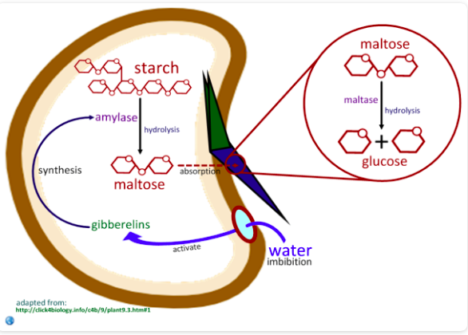

1.
2.
3.
4.
5.
6.

