9.3 – Growth in Plants
Understandings, Applications and Skills (This is what you may be assessed on)
 | Statement | Guidance
9.3 U.1 | Undifferentiated cells in the meristems of plants allow indeterminate growth.
9.3 U.2 | Mitosis and cell division in the shoot apex provide cells needed for extension of the stem and development of leaves.
9.3 U.3 | Plant hormones control growth in the shoot apex
9.3 U.4 | Plant shoots respond to the environment by tropisms.
9.3 U.5 | Auxin efflux pumps can set up concentration gradients of auxin in plant tissue.
jk9.3 U.6 | Auxin influences cell growth rates by changing the pattern of gene expression.
9.3 A.1 | Micropropagation of plants using tissue from the shoot apex, nutrient agar gels and growth hormones.
9.3 A.2 | Use of micropropagation for rapid bulking up of new varieties, production of virus-free strains of existing varieties and propagation of orchids and other rare species.

- Draw and label diagram of a dicot plant below.

- Draw and label diagram of a cross section of dicot stem below.

9.3 U.1 Undifferentiated cells in the meristems of plants allow indeterminate growth.

- Define meristem

- Distinguish between apical and lateral meristems in terms of location and function in the stem.

- Describe the function of the axillary bud.

- Explain where lateral meristematic growth takes place?

9.3 U.2 Mitosis and cell division in the shoot apex provide cells needed for extension of the stem and development of leaves.

- Explain why meristem cells are more likely to be in mitosis than cells found in other parts of the plant.

9.3 U.3 Plant hormones control growth in the shoot apex

What is a plant hormone?

- Fill in the chart below.

Hormone Name | Hormone Response

- What types of physiological responses are caused by Auxin and cytokines together?

- Explain how the plant hormone Auxin effects grow in a plant cell.

9.3 U4 Plant shoots respond to the environment by tropisms.
- Define tropism.

- Define auxin.

- Explain, with the aid of a diagram, the role of auxins in phototropism.

9.3 U.5 Auxin efflux pumps can set up concentration gradients of auxin in plant tissue.

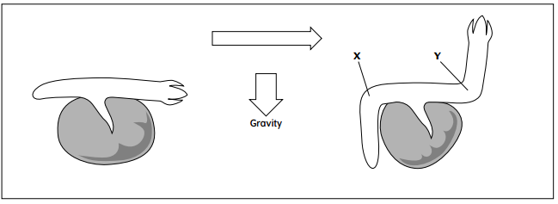
- In roots, does auxin have the same or the opposite effect as auxin in shoots?

- Why has the root bent downwards in area X?

- Why has the shoot bent upwards in area Y?

- Plant roots are also attracted towards moisture. Explain whether auxin moves towards or away from moisture. Drawing a diagram may help you.

9.3 U.6 Auxin influences cell growth rates by changing the pattern of gene expression.

- Explain one way in which Auxin effects a change in growth in the plant.

- What would happen to a plant that is unable to make Auxin or contain reduced amounts of Auxin?

9.3 A.2Use of micropropagation for rapid bulking up of new varieties, production of virus-free strains of existing varieties and propagation of orchids and other rare species.

- Explain the benefits to using micro propagation.

