9.1 – Transport in the Xylem of Plants

**Understandings, Applications and Skills** (This is what you may be assessed on)

|  |  |  |
| --- | --- | --- |
|  | **Statement** | **Guidance** |
| 9.1 U.1 | Transpiration is the inevitable consequence of gas exchange in the leaf |  |
| 9.1 U.2 | Plants transport water from the roots to the leaves to replace losses from transpiration |  |
| 9.1 U.3 | The cohesive property of water and the structure of the xylem vessels allow transport under tension |  |
| 9.1 U.4 | The adhesive property of water and evaporation generate tension forces in leaf cell walls |  |
| 9.1 U.5 | Active uptake of mineral ions in the roots causes absorption of water by osmosis. |  |
| 9.1 A.1 | Adaptations of plants in deserts and in saline soils for water conservation. |  |
| 9.1 A.2 | Models of water transport in xylem using simple apparatus including blotting or filter paper, porous pots and capillary tubing. |  |
| 9.1 S.1 | Drawing the structure of primary xylem vessels in sections of stems based on microscope images |  |
| 9.1 S.2 | Measurement of transpiration rates using potometers. (Practical 7) |  |
| 9.1 S.3 | Design of an experiment to test hypotheses about the effect of temperature or humidity on transpiration rates. |  |

**9.1 U.1 Transpiration is the inevitable consequence of gas exchange in the leaf**

1. Define transpiration.
2. Explain how the action of guard cells allows for the control of water loss.

**9.1 U.2 Plants transport water from the roots to the leaves to replace losses from transpiration**

1. Annotate the diagram to explain how water is moving through the xylem tube from the roots to the leaf. (Slide 10)

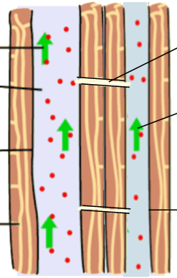

**9.1 U.3 The cohesive property of water and the structure of the xylem vessels allow transport under tension**

1. State one property of water which allows transpirationpull to be generated.

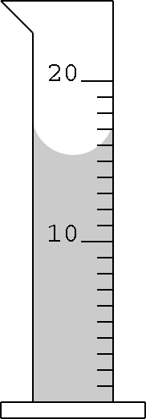

**The Meniscus**

1. Water is strongly attracted to glass. How does this explain the shape of the meniscus?

**9.1 U. 4 The adhesive property of water and evaporation generate tension forces in leaf cell walls**

1. Describe the journey water takes through the plant beginning at the roots.

**9.1 U.5 Active uptake of mineral ions in the roots causes absorption of water by osmosis**.

1. Annotate the diagram below to explain the uptake of water by mineral exchange by adding K+ ‘s and H2O’s to the root hair:
2. Explain why mineral ions need to be taken up by active transport in the roots.



**9.1 A.1 Adaptations of plants in deserts and in saline soils for water conservation**

1. Define xerophyte.
2. Describe the reproductive adaptations of xerophytes to minimize water loss
3. Describe three physical adaptations of xerophytes to minimize water loss.

1. Describe how CAM plant metabolism is an adaptation to preventing water loss.

**9.1 S.1 Drawing the structure of primary xylem vessels in sections of stems based on microscope images**

1. Draw a cross section of the xylem tube below

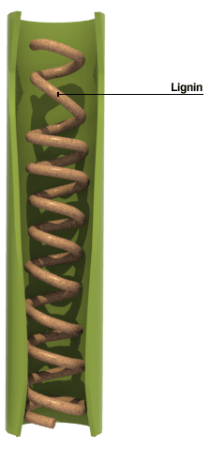 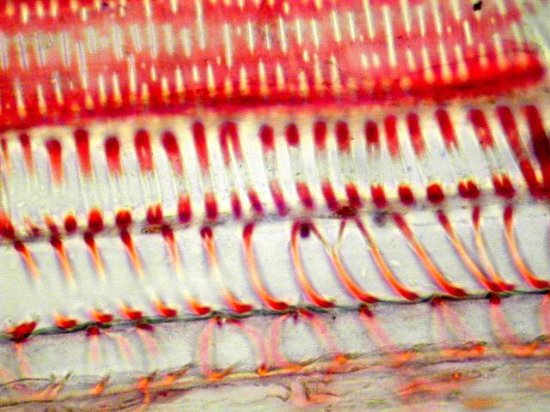

**Cellulose wall**

* 1. **S.2 Measurement of transpiration rates using potometers. (Practical 7)**

Go to: <https://www.classzone.com/books/hs/ca/sc/bio_07/virtual_labs/virtualLabs.html>

Choose the “Plant Transpiration” Lab. Follow the insructions and submit the results (save as a PDF) to managebac by Thursday April 13.

* 1. **S.2 Measurement of transpiration rates using potometers. (Practical 7)**

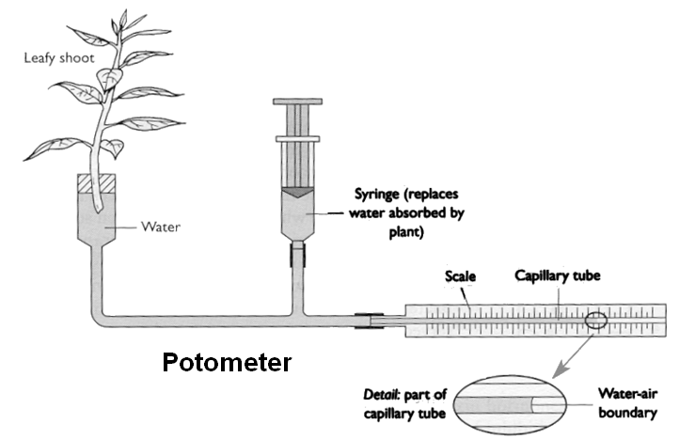

The rate of water loss from the plant through transpiration is found by measuring how far the water travels along the scale in a given time. Simon set up an experiment to compare the amount of water lost by the plant when it was light and when it was dark. These are his results.

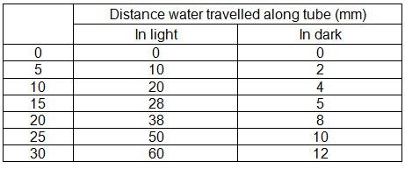

1. Plot the results for the light on a line graph. Then add the results for the dark onto the same graph.
2. What happens to the stomata of a leaf during the day? Why does this happen? How would this affect the rate of transpiration (would it increase or decrease)?

